Vermot-Desroches Matthias

Rapport de séance n°9

I started this session by updating the CAD models of the servomotor ensemble:

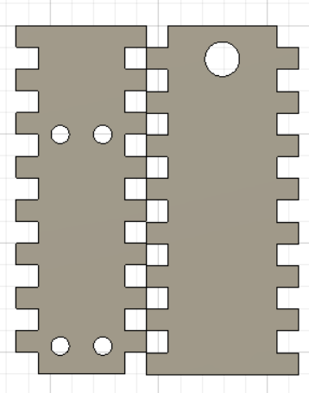

The holes on the left piece are here to fix the servomotor.

Immediately after, I used the cutting machine to make them alongside the joint pieces that will allow the ensemble to rotate:

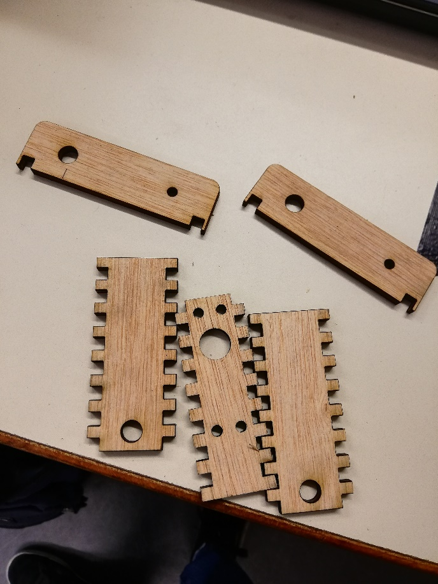

Unfortunately, the joint pieces need adjustments on the diameter of the holes and their positioning .

However, I could glue the other pieces together:

With this, I needed to see if the servomotor fitted inside, and it did.

After that, Mr. Masson, who was making another ensemble, and I spoke about the continuation aof the ensemble. We concluded by deciding that we needed the ensemble above to be higher and longer to allow the suspension to work. Plus, the piece on which the servomotor would be put had to be split into two different pieces for the motor to completely fit and not only it’s shaft.

So, I modified the CAD models, here are the newest ones:

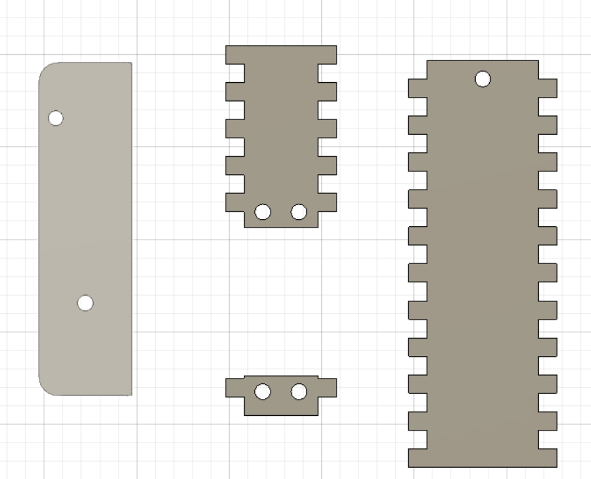

And I finished this session by making them:

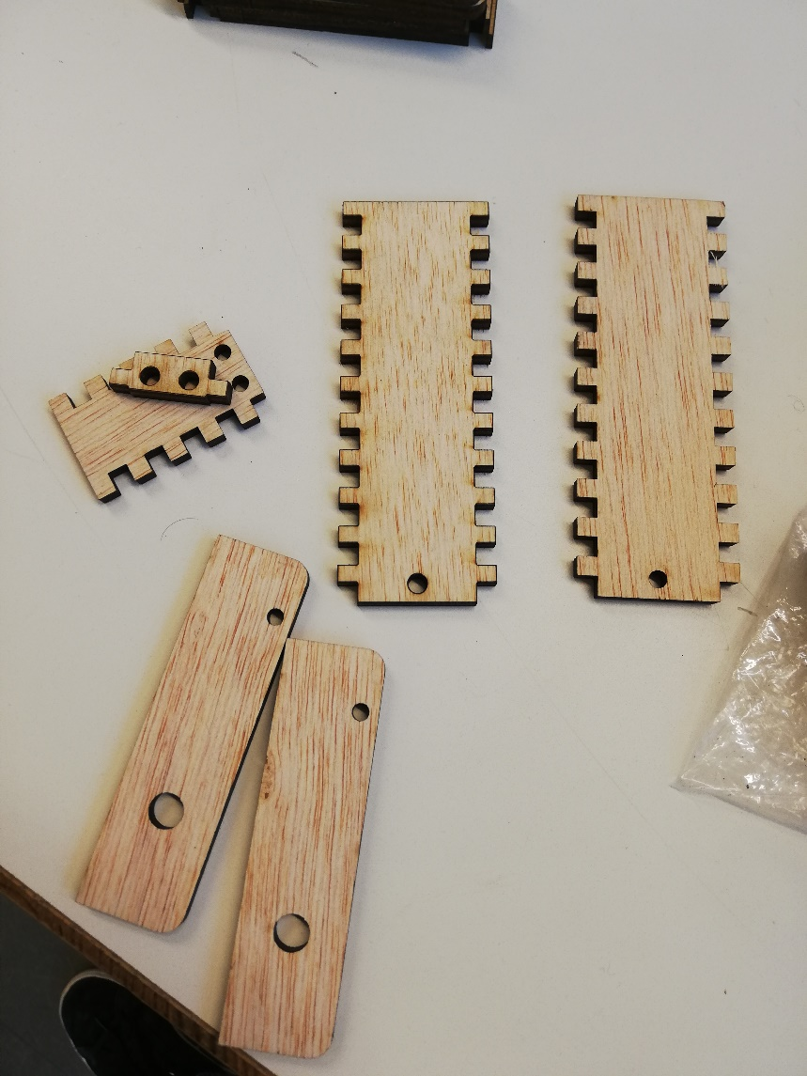

Then, I gave the pieces to Mr. Masson. He will make the ensemble during the holidays.  
However, I realized that the joint pieces still have the diameter error for one of their hole.